**Human-Infrastructure Interaction For Improved Inspection Process:**

*Technical Lead:* Vineet R. Kamat, University of Michigan

*JV Collaborators:* Jerome P. Lynch, Atul Prakash (University Michigan), SC Solutions

Task 1: Develop a platform for ubiquitous context-aware computing applications for bridge monitoring

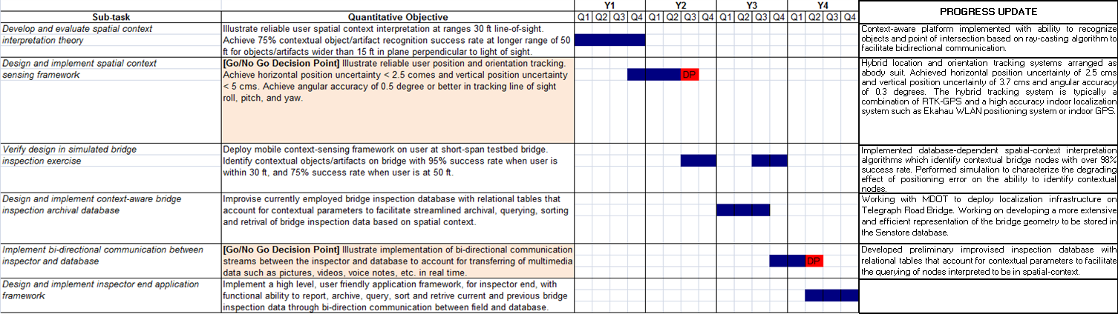

In this quarter, the research team has been successful in simulating and quantifying the effects of the errors encountered with GPS based location tracking system and the orientation tracker on the ability of the context-aware computing system in identifying the spatial context of the mobile inspector. The FEM data in the Senstore Server was chosen as a representative point cloud that describes geometry of the Telegraph Road Bridge. The behavior of GPS errors is modeled based on the RMS errors of the GPS. Typically the RMS errors depend on the GPS instrumentation being used and vary from 1-2 inches (high accuracy RTK GPS) to 3-4 meters (commercial pedestrian GPS). The simulation was conducted for a RMS error of 1.5 meter. The error distribution is described as a Weibull distribution with a shape factor of 2 (also called as Rayleigh distribution):



Figure 1: The plot shows 100 values of GPS errors integrated into the simulation with 100 runs. The values conform to a typical Rayleigh distribution, which defines the behavior of GPS error distribution.



The simulation algorithm, typically run a 100 times for each of the 8 cases (as described in the previous quarterly report), implicitly assumes GPS errors as defined by the Rayleigh distribution as shown in Figure 1.

As described above, the simulation was conducted for the 8 cases mentioned in the April 2011 quarterly report. The base case used for the 8 simulations was the same as the base case mentioned in the same report. The simulation estimates the average values of the following statistical factors:





Figure 2: The plot shows the percentage of correctly identified points (above) and wrongly identified points (below) vs the error in GPS. As the error increases, the accuracy degrades gracefully.





Figure 3: The plot shows the percentage of correctly identified points (above) and wrongly identified points (below) vs the probability of the GPS error.

1. The percentage of correctly identified points (i.e., the points in the point cloud identified by the context-aware computing algorithm as within spatial-context and are also truly in spatial-context as determined by the base case).
2. The percentage of falsely identified points (i.e., points that are interpreted by the context-aware computing algorithm as in context but are not truly in context as identified by the base case).

Figure 2 and Figure 3 plot the aforementioned statistical factors, for one of the 8 cases (case 3), against the error in GPS and the frequency of their appearance in the simulated runs respectively. The results of the simulation are summarized in Figure 4.

|  |  |  |  |  |  |  |  |  |  |  |
| --- | --- | --- | --- | --- | --- | --- | --- | --- | --- | --- |
|  | **Percentage of correctly identified points with a confidence of** | | | | | **Percentage of wrongly identified points with a confidence of** | | | | |
|  | **66%** | **80%** | **90%** | **95%** | **99%** | **66%** | **80%** | **90%** | **95%** | **99%** |
| **Case 1** | 92.16 | 88.86 | 86.93 | 86.79 | 84.44 | 9.41 | 9.04 | 11.65 | 12.06 | 15.00 |
| **Case 2** | 83.66 | 80.24 | 82.99 | 76.76 | 72.27 | 11.29 | 19.85 | 23.54 | 24.88 | 26.40 |
| **Case 3** | 99.16 | 99.05 | 98.57 | 98.33 | 98.98 | 0.58 | 0.70 | 0.97 | 1.10 | 0.75 |
| **Case 4** | 99.51 | 99.42 | 99.14 | 99.00 | 99.38 | 0.52 | 0.76 | 0.86 | 1.14 | 1.42 |
| **Case 5** | 90.22 | 87.64 | 85.79 | 84.72 | 83.85 | 9.00 | 12.06 | 13.53 | 17.43 | 15.70 |
| **Case 6** | 85.56 | 76.59 | 74.70 | 76.53 | 67.72 | 10.71 | 10.73 | 12.80 | 17.31 | 16.15 |
| **Case 7** | 99.10 | 98.89 | 98.51 | 98.38 | 98.44 | 0.62 | 0.83 | 0.92 | 1.09 | 1.00 |
| **Case 8** | 99.49 | 99.34 | 99.29 | 99.34 | 99.11 | 0.55 | 0.69 | 0.88 | 0.84 | 1.17 |

Figure 4: The summary of the results of the simulation. The major source of error in this simulation is the error in position of the inspector as modeled by the Rayleigh distribution which is an approximation of the behavior of GPS error with a RMS error of 1.5 meter.

However the point cloud used as a representation of the geometry of the Telegraph Road Bridge for this preliminary simulation was the Senstore FEM data set and is not the best representation of the geometry of the bridge. To this end, the research team has initiated a JV with Weidlinger which will help define a more accurate representation of the bridge geometry in order to develop streamlined context-aware support applications for bridge inspectors.

**Problems and Opportunities:**

**Impact Opportunities:**

*Papers Published:*

*Patents Filed and/or Granted Based on TIP-Funded Project:*

*Invited Presentations:*

*Contacts and Discussions Concerning Early Adoption:*

*Media/Press Releases:*

*Licensing or other Dissemination Arrangements:*

*Websites:*

*Engineering/Outreach:*